Chapter 6, Solution 46.

Under dc conditions, the circuit is as shown below:
2 Ω
4 Ω
i_{L}
3 A
+
v_{C}
−

By current division,

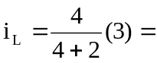 2A, v_{c} = 0V

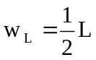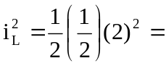 1J

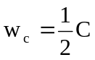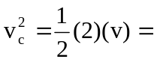 0J

